**SMART BLIND STICK**

*SPHO Project Report*

*submitted for fulfillment of*

*the requirements for the*

*Degree of Bachelor of Technology*

*Under BijuPattnaik University of Technology*

***Submitted By***

**WAGISHA RAJ SINGH ROLL NO. EL201611246**

**UTSAV RANJAN ROLL NO. EL201618249**

**BRAJRAJ CHOUDHARY ROLL NO. EL201610250**

**SIDDHARTH KUMAR ROLL NO. EL201610263**

**HIMANSHU SHEKHAR ROLL NO.EL201610289**

**RAHUL KUMAR PATNAIK ROLL NO.EL201610273**



*Batch 2016– 2020*

***Under the guidance of***

**Prof. MRUTYUNJAYA MANGARAJ**

**SMART BLIND STICK**

**NATIONAL INSTITUTE OF SCIENCE AND TECHNOLOGY**

Palur Hills, Berhampur, Odisha- 761008

[www.nist.edu](http://www.nist.edu)

ABSTRACT

This Smart stick will have an Ultrasonic sensor to sense distance from any obstacle, LDR to sense lighting conditions and a RF remote using which the blind man could remotely locate his stick. All the feedbacks will be given to the blind man through a Buzzer

**INTRODUCTION**

“I CANNOT CHANGE THE DIRECTION OF THE WIND, BUT I CAN ADJUST MY SAILS TO ALWAYS REACH MY DESTINATION” -JIMMY DEAN.

So yes, technology can indeed neutralize human disability with this in mind let us use the power of ARDUINO and some

SENSORS to build a **Blind Man’s Stick** that could perform more than just a stick for visually impaired person.

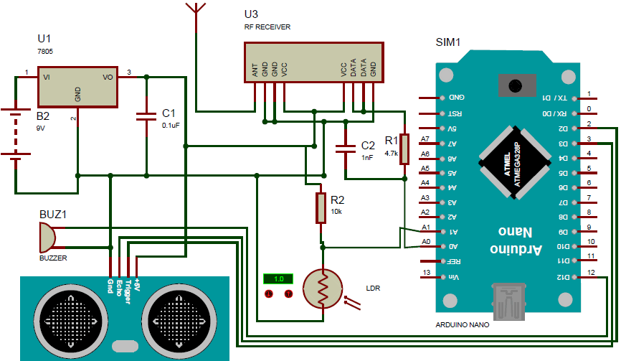

**OUTCOME**

* Independence is the building methodology in achieving dreams goals and objective in lives, so the main purpose of this project is to produce a prototype that can
* 1.detect object or obstacles in front of users,
* 2. sense lighting and,
* 3. Locate the stick.
* It will guide the users so that they don’t have to depend on any other person.

**WORK DONE TILL DATE**

* **Implemented the model of blind stick using ARDUINO, US SENSOR, LDR SENSOR, and BUZZER only.**
* **Total coding part has not been finished yet but, distance measurement using ultrasonic sensor has been tested successfully and it’s working.**

**Signature of the Advisor**